### Experiment – No-11

|  |  |  |
| --- | --- | --- |
| Objective: Program to display the pattern. | | |
| Scheduled Date | Compiled Date | Submission Date |
| 09-Jan-2021 | 09-Jan-2021 | 10-Jan-2021 |

### Program : A program to display the pattern.

### *****

### ****

### ***

### **

### *

### Algorithm

### Step 1 - Start

### Step 2 - Input variable i,j,row.

### Step 3 - Read variable of row.

### Step 4 – Apply loop.

### (i=row;i>=1;--i)

### Step 5- Apply inner loop

### (j=1;j<=I;++j)

### Step 6- Print Pattern.

**Program**

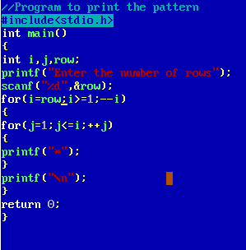

### Output Screen

### C:\Users\WIN10\Pictures\ss6.png